**Scenario:**

State's Electricity Board needs to automate its billing process. As part of the extension implementation, calculating bill amount for each user is one of the requirement.

**Functionalities:**

1. Display a form to get the EB bill details.

2. Calculate the bill amount based on the details given by the user.

**Model,**

EBBill model class is already given for your reference.

**Controller,**

A controller named '**EBBillController**', is given for you.

**Implement the following 3 actions,**

**1) EBBill (no argument)**

This action will display a form as shown in the sample below using **EBBill.cshtml**.

The form in the view must be bound to  '**EBBill**' model. On submit, 'EBBill' action with argument must be invoked.

*Return type must be****ActionResult****.*

**2) EBBill (HttpPost)**

This action will accept '**EBBill**' Model as parameter.

a)Calculate the bill amount based on the values in the model.

b)Assign the bill amount to the property 'Bill_Amount' in the 'EBBill' object.

c)Display the same view with calculated bill amount as shown in the sample input/output.

*Note : On this action property POST must be given*

*Return type must be****ActionResult*.**

Calculate the bill amount based on the given rules:

a)Units upto 50 then,  cost =  50 *1

b)Units  > 50 and <=100 then,  cost =  50 *1 + 50*2

*Example: Units is 78 then, cost = 50 *1 + 28 *2*

c)Units  > 100 and <=200 then,  cost= 50 * 1 + 50 * 2 + 100 *3

*Example: Units is 135 then, cost = 50 *1 + 50 *2 + 35*3*

d)Units  >200 then,  cost= 50 * 1+ 50 * 2 + 100 *3 + remaining units*5

Example: Units is 450 then, cost = 50 *1 + 50 *2 + 100*3 + 250 * 5

**3) Print**

On clicking the 'href' print in the view, this action must be invoked.

This action must display the Bill details that is already available in 'EBBill' Model object.

*Return type must be****ActionResult.***

**Implement the following Views:**

**1. EBBill.cshtml**

a)Create a **form**mapped to **EBBill Model using HTML Helper.**

**NOTE : While creating the form, 'id' MUST be available ( hint : use HTMLHelper )**

id="Bill_No"  
id="Consumer_Name"  
id="Pre_Reading"  
id="Cur_Reading"  
id="Submit"

b) Implement a **Link**for**'Print' .**On clicking this link, the 'Print' action must be invoked and the bill details must be displayed.

**2) Print.cshtml**

This view must display the values in the EBBill object as shown below.

*Hint: You are free to choose ANY CSS look and feel.*

**Sample Input/Output**

**URI,**

**EBBill/EBBilll**

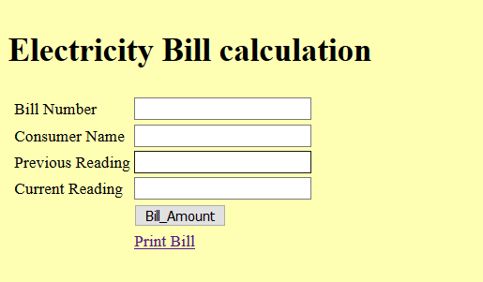

**On Submit,**

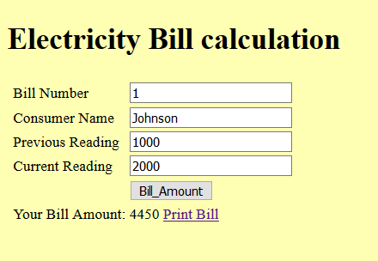

**On Clicking the link 'Print Bill'**

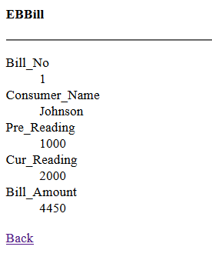

Answer

1.EBBill.cs

//THIS IS FOR REFERENCE ONLY. YOU ARE NOT REQUIRED TO MAKE ANY CHANGES HERE

using System;

using System.Collections.Generic;

using System.Linq;

using System.Web;

namespace ASP_App1.Models

{

public class EBBill

{

public int Bill_No { set; get; }

public String Consumer_Name { set; get; }

public int Pre_Reading { set; get; }

public int Cur_Reading { set; get; }

public int Bill_Amount { set; get; }

}

}

2. EBBillController.cs

using System;

using System.Collections.Generic;

using System.Linq;

using System.Web;

using ASP_App1.Models;

using System.Web.Mvc;

namespace ASP_App1.Controllers //DO NOT change the namespace name

{

public class EBBillController : Controller //DO NOT change the class name

{

// Implement 'EBBill' action

public ActionResult EBBill()

{

return View();

}

// Implement 'EBBill' action as HttpPost

[HttpPost]

public ActionResult EBBill(EBBill EBBill)

{

int units=EBBill.Cur_Reading - EBBill.Pre_Reading;

if(units<=50)

{

EBBill.Bill_Amount=50*1;

}

else if(units>50 && units<=100)

{

int temp=units-50;

EBBill.Bill_Amount=50*1+temp*2;

}

else if(units>100 && units <=200)

{

int temp=units-100;

EBBill.Bill_Amount=50*1+50*2+temp*3;

}

else if(units>200)

{

int temp=units-200;

EBBill.Bill_Amount=50*1+50*2+100*3+temp*5;

}

ViewBag.Message="Your Bill Amount: " + EBBill.Bill_Amount;

TempData["customer"]=EBBill;

return View(EBBill);

}

// Implement 'Print' action

public ActionResult Print()

{

if(TempData.ContainsKey("customer"))

{

EBBill EBBill=(EBBill)TempData["customer"];

ViewBag.Bill_No=EBBill.Bill_No;

ViewBag.Consumer_Name=EBBill.Consumer_Name;

ViewBag.Pre_Reading=EBBill.Pre_Reading;

ViewBag.Cur_Reading=EBBill.Cur_Reading;

ViewBag.Bill_Amount=EBBill.Bill_Amount;

}

return View();

}

}

}

3. EBBill.cshtml

@model ASP_App1.Models.EBBill

@{

Layout=null;

}

<!DOCTYPE html>

<html>

<head>

<title>EBBill</title>

</head>

<body style="background-color:khaki;">

<div>

<h1>Electricity Bill calculation</h1>

@using(Html.BeginForm())

{

<table>

<tr>

<td>Bill Number</td>

<td>@Html.TextBoxFor(model => model.Bill_No,htmlAttributes:new{id="Bill_No"})</td>

</tr>

<tr>

<td>Consumer Name</td>

<td>@Html.TextBoxFor(model => model.Consumer_Name,htmlAttributes:new{id="Consumer_Name"})</td>

</tr>

<tr>

<td>Previous Reading</td>

<td>@Html.TextBoxFor(model => model.Pre_Reading,htmlAttributes:new{id="Pre_Reading"})</td>

</tr>

<tr>

<td>Current Readingr</td>

<td>@Html.TextBoxFor(model => model.Cur_Reading,htmlAttributes:new{id="Cur_Reading"})</td>

</tr>

<tr>

<td colspan="2"><input type="submit" id="Submit" value="Bill_Amount" /></td>

</tr>

<tr>

<td>

@Html.ActionLink("Print Bill","Print")

</td>

</tr>

<tr>

<td colspan="2">

@if(ViewBag.Message!= null)

{

@ViewBag.Message

}

</td>

</tr>

</table>

}

</div>

</body>

</html>

4.Print.cshtml

@{

Layout=null;

}

<!DOCTYPE html>

<html>

<head>

<title>Print</title>

</head>

<body>

<div>

<h2>EBBill</h2>

<hr />

Bill_No

<br />

@ViewBag.Bill_No

<br />

Consumer_Name

<br/>

@ViewBag.Consumer_Name

<br />

Pre_Reading

<br/>

@ViewBag.Pre_Reading

<br />

Cur_Reading

<br />

@ViewBag.Cur_Reading

<br />

Bill_Amount

<br />

@ViewBag.Bill_Amount

<br />

@Html.ActionLink("Back","EBBill")

</div>

</body>

</html>